Docker is PAAS as a tool
chat allows you to build test and deploy application quickly
Docker image:
application, code configuration, and all dependencies
are packaged into a single file is called docker image
now to create docker image
docker image can be created on Dockerfile
Dockerfile:
its a set of instructions to create a image
Can we install docker on windows.
No, we cannot install docker as a core software/program but docker nas provided way to install on windows called docker desktop
when we install docker desktop.it automatically spin up Linux
virtual machine on top of windows (oracle virtual machine)
Container: Its a group of isolated processess, its an instance
or a server for that application
how does docker/container works internally?
what are c groups and name spaces in linux and how it is related to docker› what is linux container:
In normal virtualised environment one or more VM runs on top of physical machine using hypervisior
container on docker uses linux kernel features like namespace, c-group/control group. ch-root to create a container on top of os and automate the application development on a container
containers are isolated in host(VM) using 3 linux features

Namespace, cgroup ad chroot.
1. namespace : process isolation requires separation from other processes which is achieved from default
Linux feature called as namespace
namespace helps us to separate and group some process from other process
Some namespaces are PID, UFS (isolated kernel & version identifier), GID , cgroup , net(network interfaces), IPC,
Mount, User
2. cgroup ( resource limiter) : Cgroup will helps us to control the access, creation and deletion of files.
The resources used by container is managed by Linux cgroup
We can decide on how much CPU and memory resources a container should use using cgroup ex: CPU, Memoy
(RAM), sockets(Port), devices (usb).
3. chroot: it will create root directory

Docker file instructions:
FROM: to pull the image
WORKDIR: it is similar to CD, to define working directory we use WORKDIR ex: WORKDIR /home, WORKDIR /lib
RUN: it is used to update the image and commit and also used to run commands and commit it.
COPY: Instructions will copy new file from source path to container file system path
ADD: ADD will do the same thing as copy, but add allows us to do URL’s , tar or zip file as a source file, while executing it extract the data and copy
Arg: docker build -t imagename --build -arg TEST=/test
Env: docker run -d -e TEST=”5”
Difference between ENV & ARG?
ARG-
Values are available in docker file during building the docker image
values are not available after image is built or running container won’t have access.
ENV-
It is mainly meant to provide default values for your future environment variables.
Running docker applications can access environment variables.
It is a great way to pass configuration values to your project.
-e – environmental variable for container which can be accessed anywhere inside container.

FROM ubuntu:24.04

ENV DEBIAN_FRONTEND=noninteractive ## Do not ask any interactive questions. Just use default answers.##

RUN apt-get update && \
apt-get install -y apache2 && \
apt-get clean && \
rm -rf /var/lib/apt/lists/*

EXPOSE 80

CMD ["apachectl", "-D", "FOREGROUND"]

EXPOSE: it is used to make port available for all container in same cluster.
PUBLISH: publish is used to map port inside container to the port of host machine, where the same container is in run.

Difference between CMD and ENTRY POINT
When both commands are present CMD becomes argument to ENTRY POINT. We can override CMD at run time, but we cannot override ENTRY POINT.
Can we have two or more CMD or ENTRY POINT commands?
Yes, but it will consider the last CMD or ENTRY POINT only, remaining will be ignored.

How do I know image uses which port?
By using docker hub documentation I will come to know image is using which port.
Port mapping:
It will inform the docker daemon to associated port of container to the host machine.
There are 2 ways:
-p: It maps individual port of container to the port of host machine.
Example: -p <hostport>:<containerport>
-p 8888:8080
-P: All ports of container is used to same port of the host machine.
Example: docker run -it <imageid> -P

When a Docker container runs, it has its own isolated network with its own internal ports.
Example:
A Node app inside a container might run on port 3000, or a Spring Boot app might run on 8080.
But your host machine cannot access it unless you map ports.
Port mapping binds a container's port to a port on your host machine.

Advanced Combinations
IP Specific Binding: You can restrict access to only the host machine by adding 127.0.0.1 before the host port: -p 127.0.0.1:8080:80.
Multiple Ports: To map more than one service, simply use the -p flag multiple times: -p 8080:80 -p 9090:443.
Port Ranges: You can also map a range of ports at once: -p 8000-8010:8000-8010.
Dynamic Mapping: If you omit the host port and only provide the container port (e.g., -p 80), Docker will automatically assign a random available port on your host machine.
--------------------------------------------------------------------------------------------------

Docker build: it is a command used to build the images
Syntax: docker build -t <image name> . or docker build -t <image name>:<tag> .
Or docker build -t <image name> -f Dockerfile
Docker run: it is a command used to create the container from the image
Syntax: docker run -it <image name>:<tag>
-it : interactive mode
-d: detached mode
Docker ps: it is used to list running containers in local machine
docker ps -a : it is used to list all the containers in local machine
Docker images: it is a command used to list all the images exist in local machine
Docker exec: it is used to get inside the running container. Syntax: docker .exec -it <container id> /bin/bash (without /bin/bash I can give just “bash” as well)
Docker exec -it containerid bash
Without base image how to create an image? Or how to create own image or base image?
FROM scratch, it doesn't pull any images the images which is empty
Docker rmi -f imageid: to delete the docker images
Docker rm -f containerid: to delete the containers

docker run -p 8080:8080 -p 50000:50000 --restart=on-failure -v /root/tomcat/webapps:/var/jenkins_home jenkins/jenkins:lts-jdk21

docker run -d -p 8081:8080 --restart=on-failure -v /data/webapps:/usr/local/tomcat/webapps --name my-tomcat tomcat:9-jdk21

Volumes and binds/ type of layers/Types of volumes:
Docker containers doesn't store persistent data, any data return to persistent layer will no longer be available once the container stops running.
To solve the problem of persistent data from a container , docker has two options
Volumes
bind mount
Bind mount: It is a file or a folder stored anywhere on container host file system, mounted into a running file system.
It exist in host machine so process outsider of docker can also modify it.
Note: (Disadvantage)
Non docker process on docker host or docker container can modify data at anytime
Syn: -v hostmachinefile/folderpath:containerfile/folderpath
Volumes: single volume can be attached to multiple containers. Volumes are maintained by docker hub no one can access the volume outside the container, this is mountable entity can be used to store persistent data
Volumes are stored in host file system but which is managed by docker, non-docker process should not modify this part of file system.
Create volume syntax: docker volume create volumename
Docker inspect: if you want to get more information or details of container or volume we use docker inspect.
Syn: docker inspect container id or volume id
List the volumes: docker volume ls
Inspect the volume: docker inspect volume ls
Mount the volume: -v volume:containerpath (container path : /usr/local/tomact/webapps)

Docker tag: it is used to tag the image with different name or it is used to rename the image
Syntax: docker tag <name of the existing image>:<tag> <new or existing name of the image>:new tag
Docker registry: place where docker images are saved.
Default docker registry is docker hub other registries are amazon ECR, nexus registry etc…
Docker login: command to communicate with docker hub/docker registry
We need to login to docker registry before pushing or pulling the images
Syntax: docker login -u <username> -p <password> -h <docker registry name>
How do you list all containers for a particular image?
Docker ps -a --filter ancestor=<image name>

How to check whatever execution is going on in a container or how to check logs of the container?
Sudo docker logs <container id>
We can check only running container

How to list id of running container?
Docker ps -q
Docker ps -a -q: to list all the stopped container
How do you delete all running container
Docker stop $( sudo docker ps -q )
Docker rm $( sudo docker ps -a -q )

How to check command execution is successful or not
After execution, if it is success it will display container id otherwise it will display errors

Difference between kill and stop?
Stop: it will have grace period to stop process inside the container (10sec)
Kill: it will forcefully stop the container without thinking of any process running.
Pause: it will pause all process within one or more container.

Advantages of Multistage build:
Multistage build is used to harden the docker images
Multistage build helps in reducing docker image size
In Multistage build we use light weight images such as alpine and Dabian.net images
Each FROM instructions can use different base image.

What does multistage build mean in Docker?
A multistage build lets you use multiple FROM instructions in a single Dockerfile.
Each stage has a purpose (build, test, runtime), and only the final stage becomes the actual image.
This is commonly used to harden Docker images by:
- Removing build tools (compilers, package managers)
- Reducing image size
- Minimizing the attack surface
- Shipping only what is strictly needed to run the app

Why multistage builds harden images
Without multistage builds:
- Your image may include gcc, npm, maven, source code, and secrets
- Larger images = more vulnerabilities
- Attackers get more tools if the container is compromised
With multistage builds:
- Build tools exist only during build time
- Final image contains just the runtime + compiled app
- Smaller, cleaner, safer image

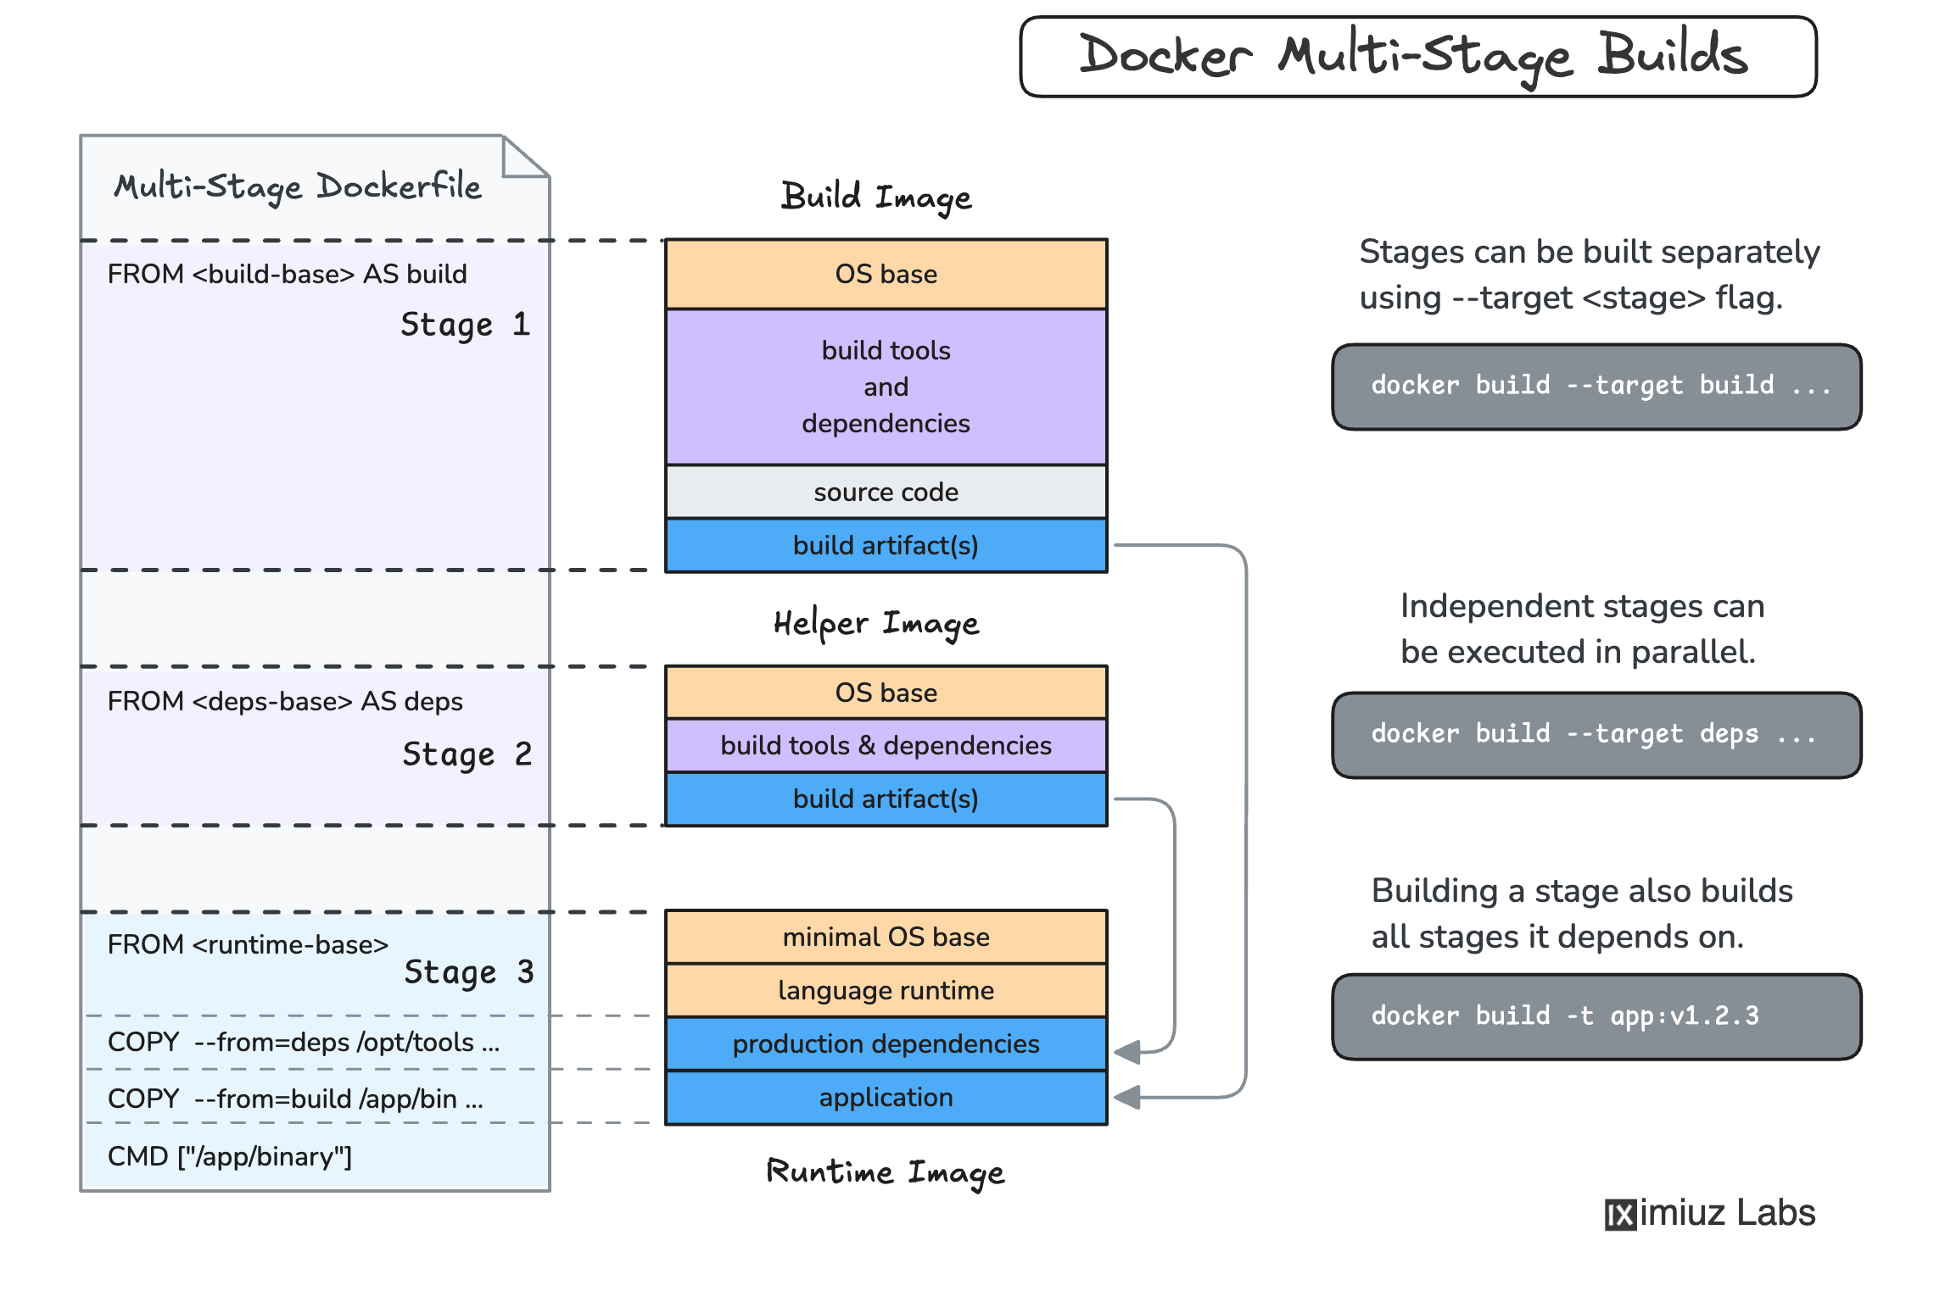

Dangling images: images without name and tag and which are not used by any container are called dangling images
How to list dangling images only?
Docker images --filter dangling=true
If dangling=false it will list all images other than dangling images
To delete only dangling images
Docker rmi $( sudo docker images -q --filter dangling=true)
Docker objects: image, container, volume, networks.
How do you check which are all ports mapped on to container?
Docker port container-id
Prune: remove all stopped container, image and volume.
Syntax: docker image prune
Remove all dangling images or unused images

# Stage 1: Base/Dependency Stage
FROM node:18-alpine AS deps
WORKDIR /app
COPY package.json package-lock.json ./
RUN npm ci

# Stage 2: Builder/Build Stage
FROM node:18-alpine AS builder
WORKDIR /app
COPY --from=deps /app/node_modules ./node_modules
COPY . .
RUN npm run build

# Stage 3: Test Stage (Optional)
FROM node:18-alpine AS tester
WORKDIR /app
COPY --from=builder /app .
# RUN npm test # Uncomment to run tests

# Stage 4: Production Stage
FROM nginx:stable-alpine AS runner
WORKDIR /usr/share/nginx/html
RUN rm -rf ./*
COPY --from=builder /app/build .
EXPOSE 80
CMD ["nginx", "-g", "daemon off;"]

psql -h localhost -p 5432 -U myuser -d mydb
CREATE TABLE users (
id SERIAL PRIMARY KEY,
name VARCHAR(100) NOT NULL,
email VARCHAR(150) UNIQUE NOT NULL,
age INT,
created_at TIMESTAMP DEFAULT CURRENT_TIMESTAMP
);
Data only container:
It is used for persistent data storage example : databases in docker. The data only container does nothing else except exposing a data volume. It is used to add volume to other container.
Postgres- used to save and pull the data from database. Postgres in one of the databases, we can use it as container.
psql -h localhost -p 5432 -U myuser -d mydb
Mysql:
docker run --name some-mysql -e MYSQL_ROOT_PASSWORD=my-secret-pw -d mysql:tag
docker exec -it some-mysql mysql -u root -p
my-secret-pw
Docker Networks/networking:
For docker containers to communicate with each other and the outside world via the host machine, there has to be a layer of networking involved that is docker networking.
Different types of docker networks:
Bridge/host networks
Overlay networks
Macvlan network
Docker default networking (docker0):
When docker is installed a default bridge network named docker0 is created, each new docker container is automatically attached to this network, unless a custom network is specified.
Besides docker0 two other networks get created automatically by docker.
Host (no isolation between host and containers on this network, to the outside world when they are on the same network)
None (attached containers run on container specific network stack) or disabling all networks for a container.
Bridge/host networks:
Bridge networking is the most common network type. It is limited to containers within a single host running on the docker engine. Bridge networks are easy to create, manage and troubleshoot.
Bridge networks are usually used when your application runs in standalone containers that need to communicate.
Host: for standalone containers, remove the network isolation between the container and the docker host, and use the host networking directly.
docker run -d --name test-bridge nginx
docker run -d --name test-host --network host nginx
docker run -d --name test-none --network none nginx

To create an own network:
docker network create my-test-net
docker ps -a
docker network connect my-test-net test-none
docker rm -f 70bef47472da
docker run -d --name test-none --network my-test-net nginx
docker ps -a
docker network ls
docker inspect 7625299656b2

Overlay networks:
Overlay networks connect multiple docker demons together and enable swarm services to communicate with each other. You can also use overlay networks to facilitate communication between a swarm service and a standalone container, or between two standalone containers on different docker daemon.
This strategy removes the need to do OS level routing between this container.

Macvlan networks:
Macvlan networks allow you to assign a MAC address to a container, making it appear as a physical device on your network. docker demon routes the traffic to containers by their MAC addresses.

Docker compose / docker compose file: it is a tool for defining and running multiple container docker applications, with compose we use a YAML file to configure your application services. Then with a single command you create and start all services from your configuration.
It is a YAML file defining service, network and volumes, it is used to run multiple containers as a single service.
We can start and stop all services using single command.
Docker-compose up or docker compose up -d (detached mode)
Docker-compose down

version: "3.9"

services:
jenkins:
image: jenkins/jenkins:lts
container_name: jenkins
restart: unless-stopped
ports:
- "8080:8080" # Jenkins UI
- "50000:50000" # Agent port
volumes:
- jenkins_home:/var/jenkins_home
user: root

volumes:
jenkins_home:

docker top

docker save -o frontend.tar my_frontend_image:latest

docker commit my_container my_new_image

docker load < image.tar

docker stats

docker top containerID

curl localhost:80

docker cp backend/src/server.js 90805f3f60a2:/code/src/server.js

